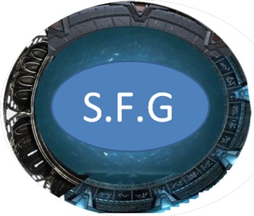

**The Stargate Fan Group Newsletter April 2013**

**[](http://stargatefangroup.weebly.com/index.html) [](https://www.facebook.com/stargate.fg?ref=tn_tnmn#!/groups/Stargate.Fan.Group/) [](https://twitter.com/StargateFG)[](http://www.youtube.com/user/stargatefansgroup) [](http://www.myspace.com/stargatefangroup) [](http://steamcommunity.com/groups/stargatefansgroup) [](http://stargatefangroup.wikia.com/wiki/Main_Page) [](http://www.moddb.com/groups/stargatefangroup-the-official-stargate-fan-page)**

**__________________**

This April has been an extremely exiting month with many great surprises and of course the release of Stargate Unleashed! Six new SFG pages have also been created: Stargate Infinity, Stargate Worlds, Stargate Resistance, Stargate the Alliance, Stargate Unleashed and Stargate United. Like now! Stargate United is a new SFG coalition that has been created to gather all the many Stargate groups created by fans into one massive coalition so that we can direct all of our efforts to really make a difference. SFG has very good connections with many other well-known Stargate Groups and the coalition is slowly forming and with Stargate United only having been around one day, one major group has already responded! Stargate Special Forces! If you have a Stargate Group and you wish to join the Coalition contact us on any of our pages or email us at [Stargatefangroup@gmail.com](mailto:Stargatefangroup@gmail.com) .For those of you disappointed that Stargate Unleashed is only available for Apple and android products, don’t despair for SG: Unleashed is coming to Steam Greenlight! So stay tuned and keep posted.

If you have any questions visit any of our pages and we will help (Links at the top). If you have any exiting news or views etc that you would like to share you are welcome to post any time. Feel free!

_______________________________________________________________________________________________________________________________________________________